To-Do List Project Documentation

Introduction
The To-Do List App is a simple yet powerful Python program designed to help users add, view, and delete tasks.
It demonstrates key Object-Oriented Programming (OOP) concepts such as classes, objects, methods, constructors, and lists.
This project allows users to manage their daily tasks efficiently through a menu-driven console interface.
It is built entirely using core Python, making it an excellent beginner-level project for learning programming fundamentals.

2. Objective
The main objective of this project is to create a menu-based task management system where the user can:
Add new tasks
View all existing tasks
Delete completed or unwanted tasks
Exit the program safely
The application keeps the tasks stored in memory (using lists) while running.

3. Code Explanation (Step-by-Step)

A. Class Definition

class ToDoList:
- A class in Python acts as a blueprint for creating objects.
- Here, the class 'ToDoList' is used to store and manage all tasks.
- All methods related to task management are defined inside this class.

Constructor
def __init__(self):
self.tasks = []
- The __init__ method is a constructor that runs automatically when the class object is created. It initializes an empty list 'tasks' that will hold all user-entered tasks.
- self.tasks is an empty list that will hold all the tasks entered by the user.
- Each time a new object of ToDoList is created, it starts with an empty task list.

Add Task Method

def addtask(self):
task = input("Please enter a task: ")
self.tasks.append(task)
print(f"Task '{task}' added to the list")
- This method allows the user to add a new task using input().
- It takes input from the user and appends it to the tasks list using the append() function.
- After adding the task, it displays a confirmation message using print().
Concepts Used:
- Input handling (input())
- List manipulation (append())
- String formatting (f"...")

List All Tasks

def list_tasks(self):
if not self.tasks:
print("No task in list")
else:
print("Current Tasks:")
for index, task in enumerate(self.tasks):
print(f"Task #{index} {task}")

- This method displays all the tasks currently in the list.
- The condition if not self.tasks: checks whether the list is empty.
- If there are tasks, the program uses enumerate() to print each task with its index number.
Concepts Used:
- Conditional statements (if-else)
- List traversal (for loop)
- enumerate() for numbering items

Delete a Task

def delete_task(self):
self.list_tasks()
try:
task_to_delete = int(input("Enter the # to delete: "))
if 0 <= task_to_delete < len(self.tasks):
removed = self.tasks.pop(task_to_delete)
print(f"Task '{removed}' has been removed")
else:
print(f"Task #{task_to_delete} was not found")
except ValueError:
print("Invalid input")
- This method allows the user to delete a task by entering its index number.
- It first displays all tasks using self.list_tasks().
- The user enters the number corresponding to the task to be deleted.
- The pop() method removes the task from the list.
- The try-except block is used to handle errors like non-numeric input.
Concepts Used:
- Exception handling (try-except)
- Type conversion (int())
- List element removal (pop())

Main Function

def main():
to_do = ToDoList()

print("Welcome to the To-Do List")
while True:
print("\nPlease select one of the following options")
print("1. Add a new task")
print("2. Delete a task")
print("3. List tasks")
print("4. Quit")
choice = input("Enter your choice: ")
if choice == "1":
to_do.addtask()
elif choice == "2":
to_do.delete_task()
elif choice == "3":
to_do.list_tasks()
elif choice == "4":
break
else:
print("Invalid input Please try again")

print("Goodbye! Have A Nice Day")
- The main() function controls the overall flow of the program.
- It creates an object of the class ToDoList called to_do.
- The program continuously displays a menu using a while True loop until the user decides to quit.
- Based on the user’s choice, it calls the corresponding method.
Concepts Used:
- Object creation
- Infinite loop (while True)
- Conditional branching (if-elif-else)

Program Execution Check

if __name__ == "__main__":
main()
This ensures the main() function runs only when the file is executed directly, not when imported as a module.

Program Output

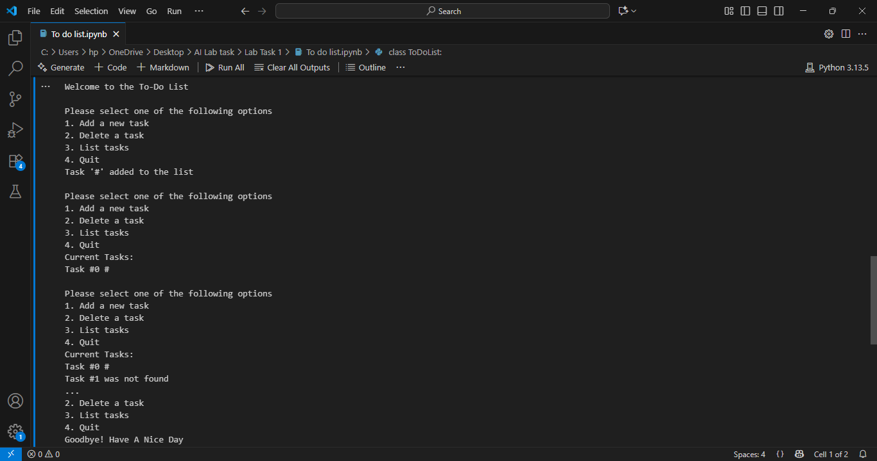

5. Key Python Concepts Used
Concept | Purpose in the Program
Class | Defines the To-Do List structure
Object | Used to access class methods
Constructor (__init__) | Initializes the task list
List | Stores all user-entered tasks
Append() | Adds a new task to the list
Pop() | Removes a task from the list
Enumerate() | Displays task numbers
While Loop | Keeps the program running continuously
If-Else | Handles user menu choices
Try-Except | Manages invalid user inputs

6. Advantages of This Program

- Simple and user-friendly
- Demonstrates OOP concepts
- Handles invalid inputs safely
- Dynamic menu system
- Can be extended easily with more features

7. Conclusion
The To-Do List Project is a great example of using Python’s OOP concepts to create real-world applications. It demonstrates how to structure programs, handle user input, and manage data using lists and loops. This project serves as a strong foundation for building more advanced task management systems.

